**DAILY ONLINE ACTIVITIES SUMMARY**

|  |  |  |  |  |  |  |  |  |
| --- | --- | --- | --- | --- | --- | --- | --- | --- |
| **Date:** | 28-05-2020 | | | | | **Name:** | K S Prajwal | |
| **Sem & Sec** | Vi A sec | | | | | **USN:** | 4AL18CS032 | |
| **Online Test Summary** | | | | | | | | |
| **Subject** | | Microcontroller and Embedded Systems, Aadalitha Kannada | | | | | | |
| **Max. Marks** | | 20,50 | | **Score** | | | 18,36 | |
| **Certification Course Summary** | | | | | | | | |
| **Course** | Computer Vision Essentials | | | | | | | |
| **Certificate Provider** | | | Greatlearning.in | | **Duration** | | | **3 hr** |
| **Coding Challenges** | | | | | | | | |
| **Problem Statement:** 1. Digital root of a number  2. Counting number of vowels in each substring of a string | | | | | | | | |
| **Status:** completed | | | | | | | | |
| **Uploaded the report in Github** | | | | | yes | | | |
| **If yes Repository name** | | | | | <https://github.com/alvas-education-foundation/KS_Prajwal> | | | |
| **Uploaded the report in slack** | | | | | yes | | | |

Online Test Details: (Attach the snapshot and briefly write the report for the same)

Certification Course Details: (Attach the snapshot and briefly write the report for the same)

Coding Challenges Details: (Attach the snapshot and briefly write the report for the same)

ONLINE TEST:

**Online Test Details:**

1. **MES:** The online test was from module 2 which was about the introduction to ARM instruction set and ARM programming using assembly language. There were 20 questions and the duration was 40 minutes. The questions were optimal and were easy. The score that I got in the test is 18/20.
2. **Aadalitha Kannada:** The online test was from all the ten chapters. All were objective type questions and were optimal. There were 50 questions and the duration was 50 minutes. The score that I got is 36/50

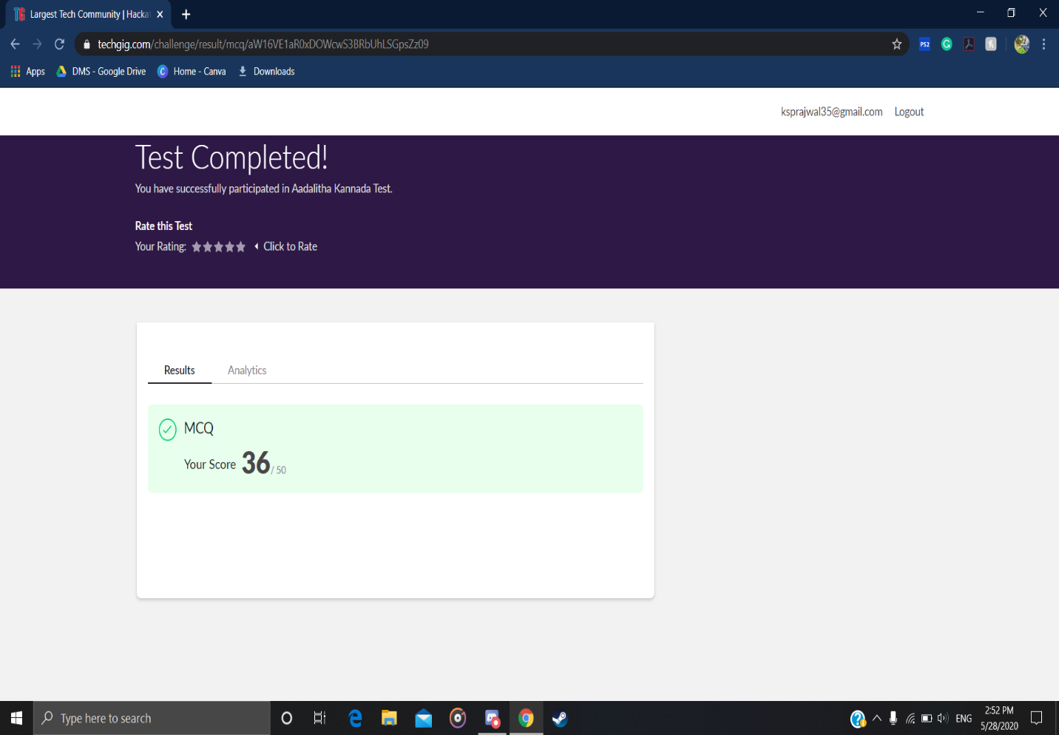

Snapshot of certification course:

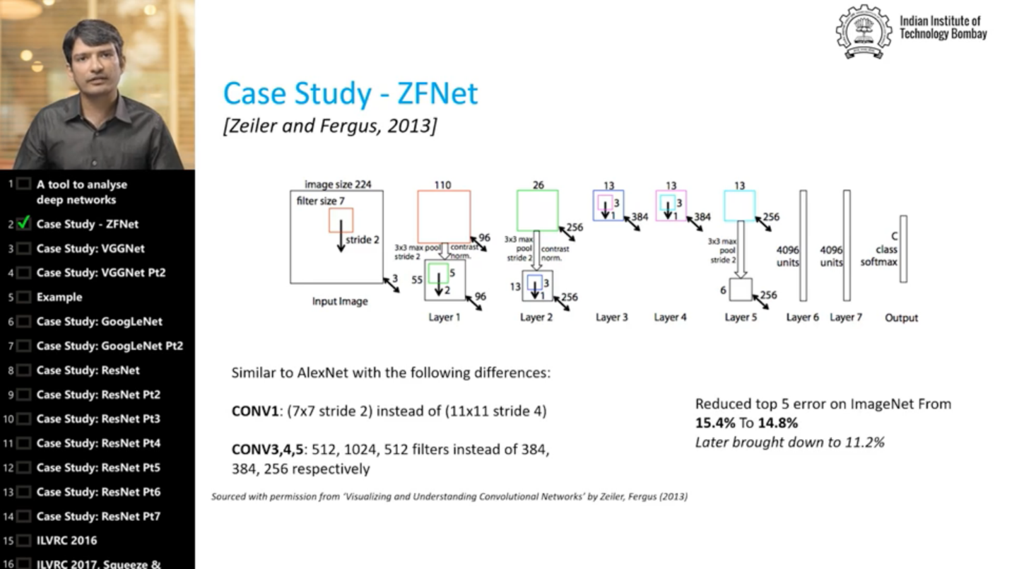

It was about the case study of ZFNet and VGGNet , google net,ResNet. They explained the difference between the CPU and GPU

**Online coding:**

Problem 1: (using C language) Write a program to print the digital root of a number.

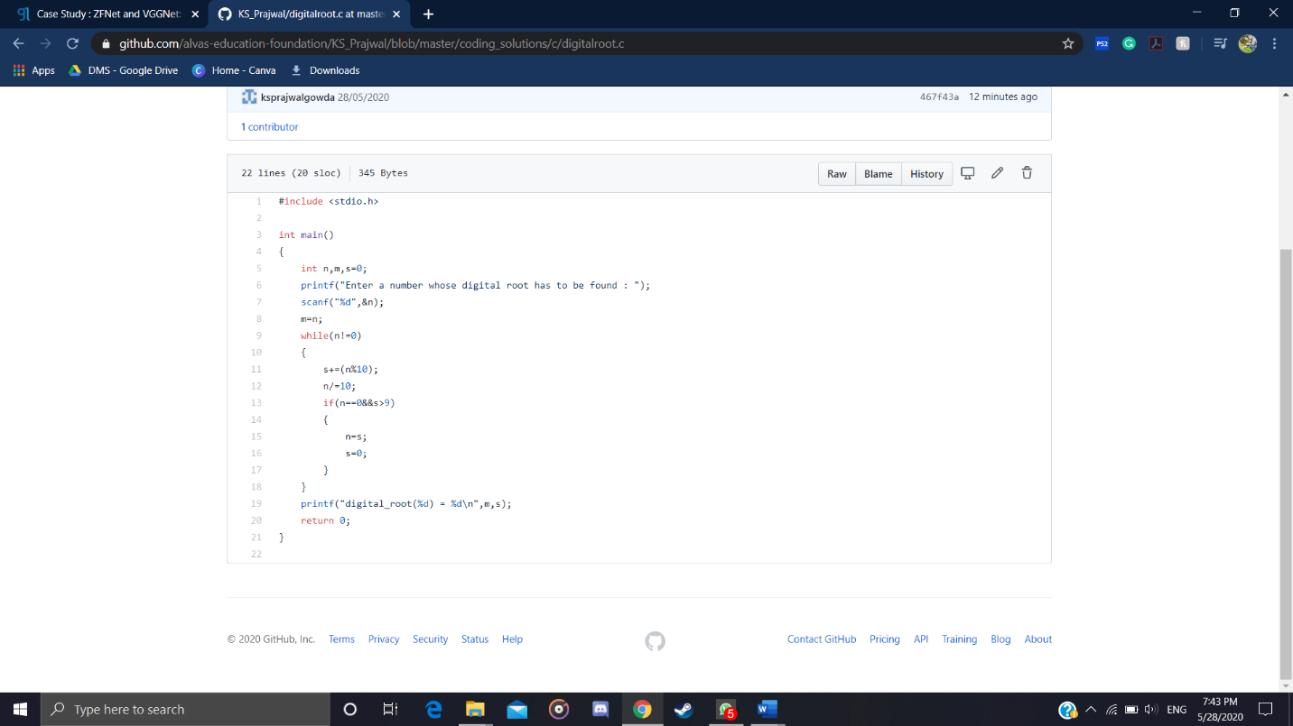

Problem 2: (Using python) Write a program have to find the presence of vowels in all possible substrings of the given string. For each given string you have to print the total number of vowels.

